Toolkit for Pathways for an Equitable and Inclusive Recovery for Immigrants, Refugees, and International Students
The integration of internationally educated immigrants and refugees is essential during this pivotal moment of history. This toolkit contains a hashtag, sample tweets, and media so you can join us in advocating for bold policy to ensure an inclusive recovery that addresses racial inequities, promotes the upward economic mobility of immigrant and refugee professionals, and recognizes the critical contributions of international students.
This campaign will be pulling from WES’ Pathways for an Equitable and Inclusive Recovery for Immigrants, Refugees, and International Students – a document that outlines key recommendations for the Biden-Harris administration to address the underutilization of immigrant and refugee talent and ensure an inclusive and vibrant economy that offers equal opportunity to all.

Join the conversation
- Link to share: http://bit.ly/wes-pathways-for-inclusive-recovery
- Tag us: @WorldEdServices and @WESGlobalTalent
- Use the hashtag: #ImmigrantsThrive

General
- The Biden-Harris administration must take bold action to ensure an inclusive & vibrant economy. We support @WorldEdServices’ 5 recommendations to support #immigrants, #refugees, & #intlstudents. #ImmigrantsThrive
Details here: http://bit.ly/wes-pathways-for-inclusive-recovery
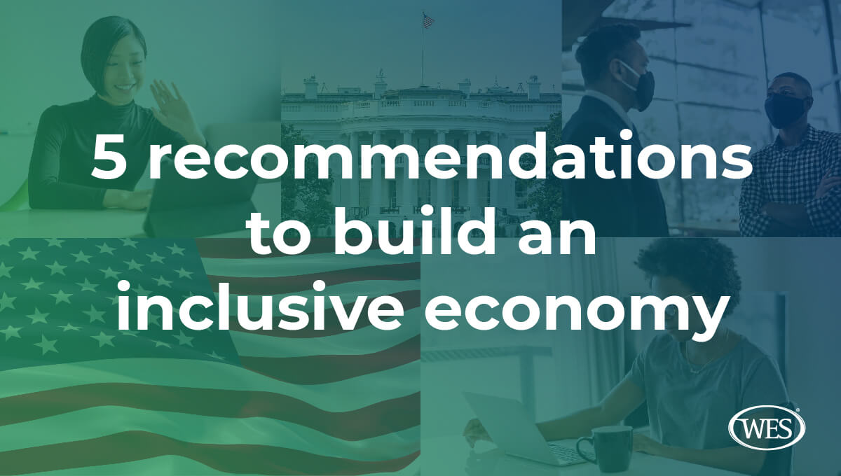
- We stand with @WorldEdServices in calling on the Biden-Harris administration to rebuild our economy and global reputation by ensuring #immigrant and #refugee economic integration. #ImmigrantsThrive.
Find the details here: http://bit.ly/wes-pathways-for-inclusive-recovery

Recommendation 1: Create a White House Office for New Americans
- The Biden-Harris administration must establish a White House Office for New Americans to create a framework for #immigrant & #refugee integration & to coordinate services across the federal gov. @WorldEdServices #ImmigrantsThrive
Details here: http://bit.ly/wes-pathways-for-inclusive-recovery
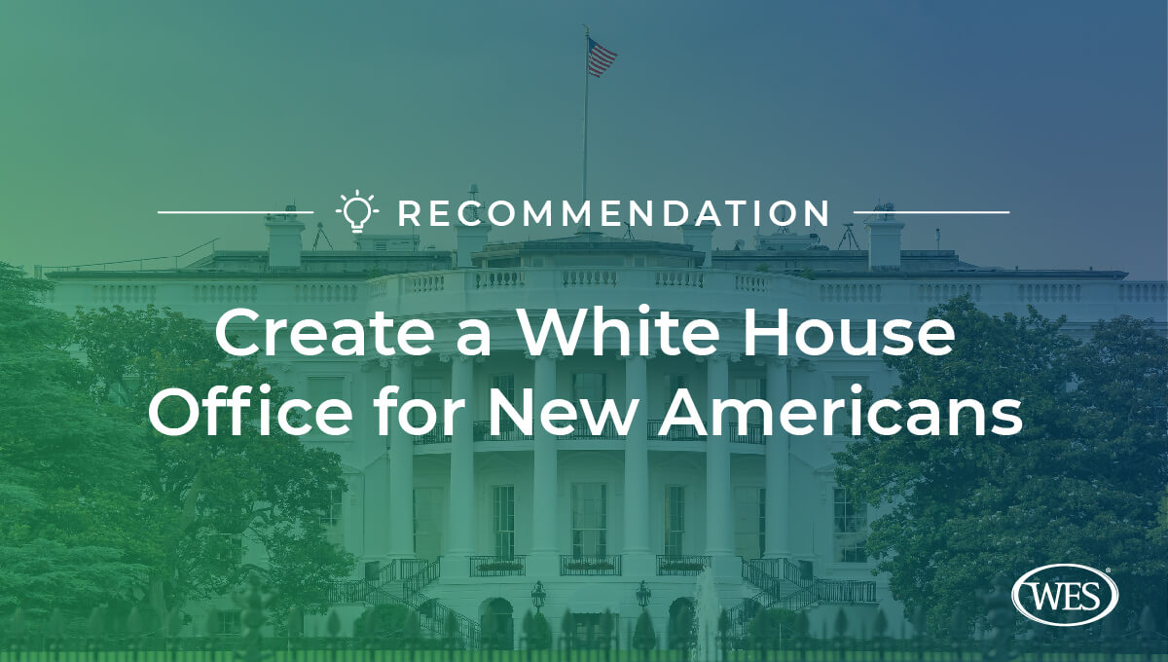
- Establishing a White House Office for New Americans must be a priority for the Biden-Harris administration.
Find the details on how a federal ONA could foster an inclusive economy here: http://bit.ly/wes-pathways-for-inclusive-recovery #ImmigrantsThrive @WorldEdServcies

Recommendation 2: Invest in proven workforce development, English language learning, and adult education models
- The federal government should coordinate its efforts to strengthen & expand adult education & workforce development programs that are equipped to serve #immigrant & #refugee professionals. @WorldEdServices #ImmigrantsThrive
Details here: http://bit.ly/wes-pathways-for-inclusive-recovery
- We support @WorldEdServices in their recommendation that the Biden-Harris administration should increase funding to address gaps in services for adult English language learners. #ImmigrantsThrive
Details here: http://bit.ly/wes-pathways-for-inclusive-recovery
- The Biden-Harris admin should increase investment in workforce development & adult education programs, like those at @TXWorkforce & @welcomingcenter, developed for #immigrant & #refugee workers. @WorldEdServices #ImmigrantsThrive
Details here: http://bit.ly/wes-pathways-for-inclusive-recovery
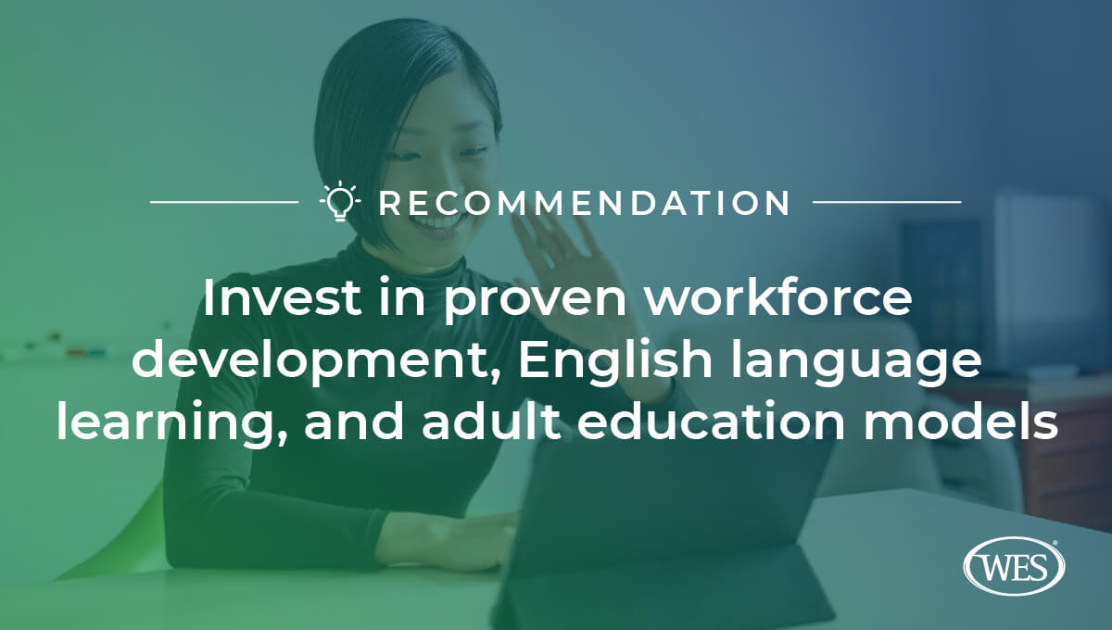
- The Biden-Harris administration should increase investment in #communitycolleges to ensure that they have the resources necessary to provide support services to #immigrants #refugees and #internationalstudents. @WorldEdServices #ImmigrantsThrive
Details here: http://bit.ly/wes-pathways-for-inclusive-recovery

Recommendation 3: Build career pathways and reduce barriers to licensure for internationally trained immigrant and refugee professionals
- We support @WorldEdServices in their recommendation to the Biden-Harris administration to support states committed to reducing barriers to occupational licensure for #immigrants & #refugees through DOL funding. #ImmigrantsThrive
Details here: http://bit.ly/wes-pathways-for-inclusive-recovery
- With the ongoing #COVID19 pandemic, we join @WorldEdServices to call on the Biden-Harris admin to improve career pathways for #immigrants & #refugees who hold international credentials in health. #ImmigrantsThrive
Details here: http://bit.ly/wes-pathways-for-inclusive-recovery
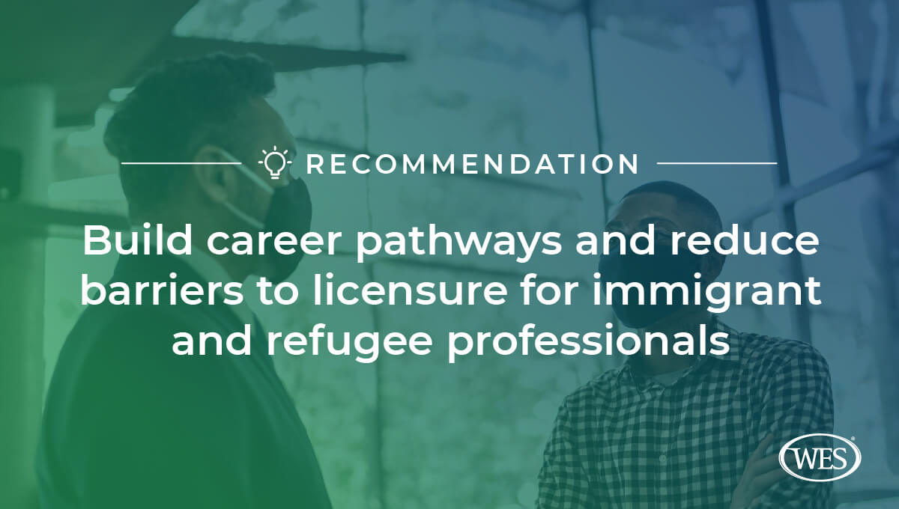
- The Biden-Harris administration should invest in opportunities for internationally trained immigrants and refugees who need U.S. clinical experience to qualify for U.S. residencies, #ImmigrantsThrive
Details here: http://bit.ly/wes-pathways-for-inclusive-recovery

Recommendation 4: Rebuild the U.S. Refugee Resettlement Program and welcome refugees into an inclusive economy
- The Biden-Harris admin should expand and strengthen the Refugee Career Pathways program in the ORR, which offers key services like career coaching, help with credential recognition, and #ESOL. @WorldEdServices #ImmigrantsThrive
Details here: http://bit.ly/wes-pathways-for-inclusive-recovery
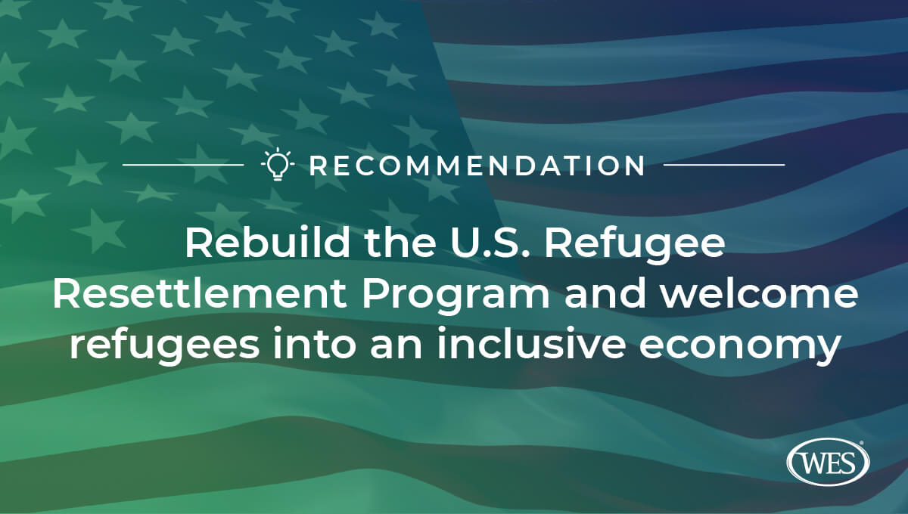
- The Biden-Harris admin should offer comprehensive pre-arrival information on #careerpathways, credential evaluation & recognition, & access to #ESOL opportunities for #refugees. @WorldEdServices #ImmigrantsThrive
Details here: http://bit.ly/wes-pathways-for-inclusive-recovery

Recommendation 5: Revive the reputation of the United States as the leading destination for international students
- #Intlstudent's contribute billions to the economy & in tuition & fees to academic institutions each year. The Biden-Harris must rescind the proposed federal rule eliminating duration of status on Day One. @WorldEdServices #ImmigrantsThrive http://bit.ly/wes-pathways-for-inclusive-recovery
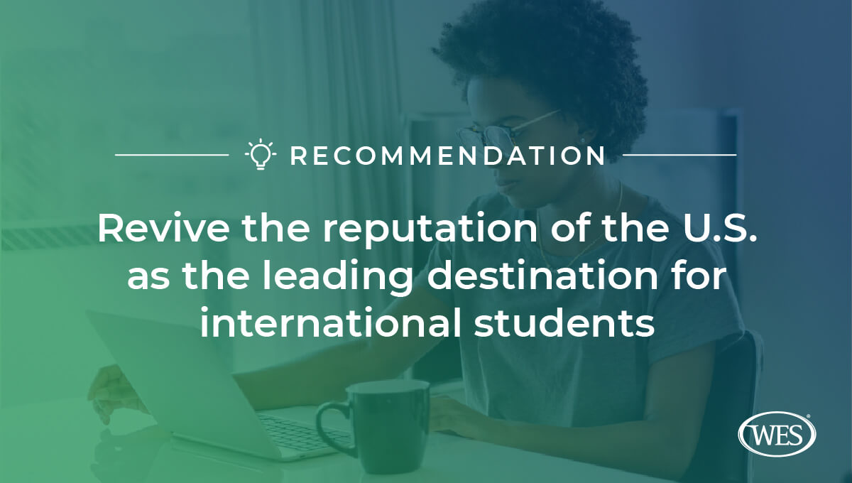
- We stand with @WorldEdServices’ recommendation that the Biden-Harris administration improve the visa process for #intlstudents by ensuring timely and transparent adjudications because #ImmigrantsThrive.
http://bit.ly/wes-pathways-for-inclusive-recovery

